We’re Going on a Mission
Meaningfully revising NWC’s mission statement using a data-driven methodology
Background
Educators have questioned the extent to which higher education mission statements are effective assertions of distinctiveness and purpose. Bowers (2013) notes that "empirical evidence is mixed on whether mission statements truly provide guiding principles or merely consist of rhetorical, broad, catch-all phrasing" (61). Maintaining that Northwest College’s mission statement should exemplify the former, President Hicswa convened a workgroup to consider how we might ascertain and act upon the collective priorities of Northwest College employees. This report outlines the workgroup’s methodology for engaging the entire campus, compiling data, and crafting a series of statements that resonate with the NWC community and drive strategic planning.
The mission statement project arose from two parallel courses of action. The first involves President Hicswa’s efforts to increase employees’ sense of ownership in the institution's directions and priorities. Using Northcutt and McCoy's (2004) theoretical framework of "Interactive Qualitative Analysis," President Hicswa conducted a "silent nominal" data-gathering activity in August 2013. Her query asked college employees to provide a written list of "priorities that we need to address in the next five years." The results of this activity – an employee-generated commitment to "Pride in: Student Experience; Place; College Community; and Fiscal Integrity" – laid the groundwork for the mission review process.

Also in fall 2013, NWC began re-structuring its approach to assessing student learning (See board book from November 2015). Both the President and the Central Assessment Team have been working steadily and inclusively toward a culture shift on campus that is more collaborative, evidence-based, and improvement-oriented.

Process
Conversations began in January 2015 about the need to formulate mission statements and student learning outcomes in ways that are measurable and that ring true to the experiences of those they impact. That dialogue led to the idea of merging Northcutt and McCoy's (2004) "Silent Nominal" research approach (designed to counteract verbal brainstorming that marginalizes those who are less comfortable voicing ideas in a public setting) with Angelo and Cross' (1993) "Teaching Goals Inventory" model (designed to help instructors identify their most vital teaching goals for a course). The resulting methodology involved the following:

Step 1: Compiling a list of themes for inclusion in the mission statement. A preliminary list was compiled in March 2015 using themes from existing NWC documents, the scholarly literature, and the August 2013 "Silent Nominal" activity. That list was supplemented with data gathered through a second activity in April 2015 in which college employees were asked to complete the sentence: "I would like our mission to include." The final list identified 72 distinct priorities that were categorized into 19 themes within 5 clusters: 1) Pride in Student Experience; 2) Pride in Student Trajectory; 3) Pride in Place; 4) Pride in Campus Community; and 5) A Culture of Excellence.

Step 2: Drafting the Institutional Priorities Inventory. List items from Step 1 were inserted into a questionnaire frame adapted from Angelo and Cross' (1993) widely-used "Teaching Goals Inventory."
The resulting "Institutional Priorities Inventory" (IPI) asks respondents to rate the level of importance they ascribe to each of the inventory's 72 priorities. It also asks respondents to consider the 19 umbrella themes and rank their top five.

Step 3: Collecting Responses. In August 2015, all employees of the college were asked to complete the IPI questionnaire. Response rates were as follows:

Constituency Group | Respondents | Total in Group | Response Rate
Classified Staff | 36 | 57 | 63%
Faculty - regular and adjunct | 67 | 146 | 46%
Professional Staff | 52 | 105 | 50%
Total | 155 | 308 | 50%

In addition, input was solicited from community members and NWC students. In September and October 2015, Personal letters were sent to 289 external stakeholders, including current and former Trustees; emeritus professors/administrators; current and former members of the Alumni Association and Foundation Boards of Directors; public school superintendents; media; city, county, chamber of commerce, and economic development representatives; legislators; banking, healthcare and University of Wyoming representatives. The public at large was reached through newspaper and radio announcements. Students were contacted in January 2016 via email messages, social media, and announcements on the MyNWC portal. 45 community members (25 in-person and 20 via email) and 134 students completed the survey.

Step 4: Analyzing Data and Finalizing the Mission Statement. Statistical analyses were conducted to determine employees’ top-rated themes, inter-question reliability within themes, and significant differences between constituency groups. The themes that rose to the top became the five mandates in the new Mission Statement, and the distinct IPI list items comprising those umbrella themes serve to operationalize how the campus lives out its Mission. Student and community input informed the final mission statement and provides insight into the different constituencies’ priorities (see visualizations below).

The result is an inclusive and clearly-defined Mission Statement that is actionable, measurable, and meaningfully tied to campus identity. We feel that the new Mission Statement will both reflect and fuel employees' commitment to continuous quality improvement.

Northwest College Mission Statement Workgroup

Stefani Hicswa  President | Gerald Giraud  Vice President of Academic Affairs and Student Services
Aura Newlin  Instructor of Sociology & Anthropology  Assessment Coordinator | Lisa Smith  Institutional Researcher
Rachel Hanan  Assistant Professor of English  Chair, Central Assessment Team | Sam Jones  2015-2016 Student Body President

References

Angelo, T. A., & Cross, K. P. (1993). Classroom assessment techniques. A handbook for faculty (2nd ed.). San Francisco: Jossey-Bass.

Bowers, B. (2013, spring). Higher education mission statements: How vital, how vacuous? New Educational Foundations, 59-66.

Northcutt, N., & McCoy, D. (2004). Interactive qualitative analysis: A systems method for qualitative research. Thousand Oaks: Sage.

EMPLOYEE PRIORITIES (larger text indicates greater importance to mission)

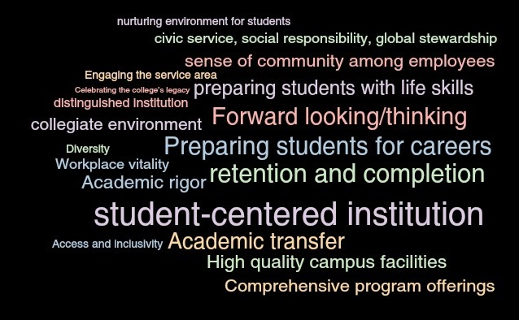

COMMUNITY PRIORITIES (larger text indicates greater importance to mission)

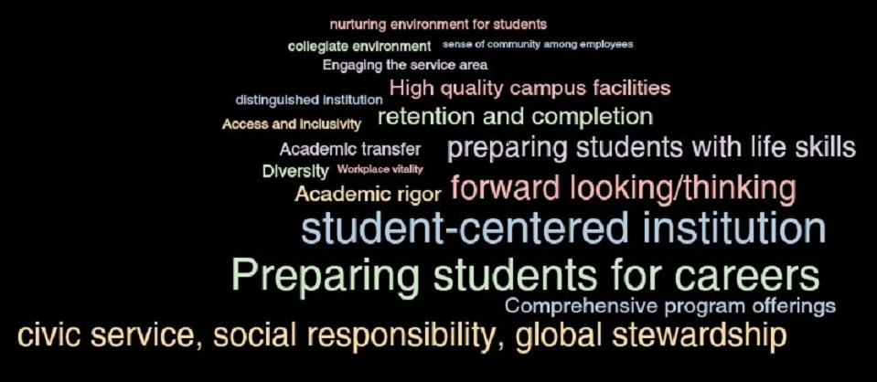

STUDENT PRIORITIES (larger text indicates greater importance to mission)

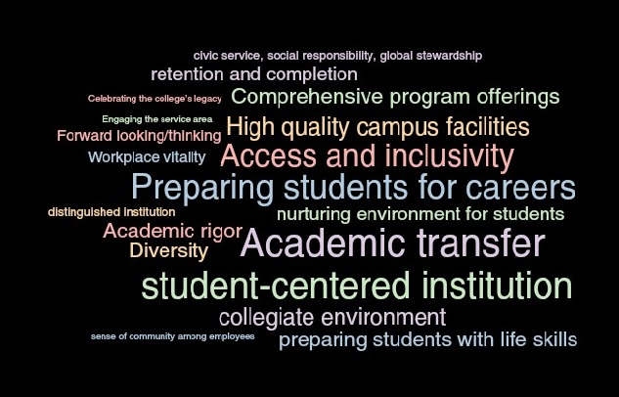

NWC Mission Statement (2016)

In the context of our global society, Northwest College:

Is student-centered
At NWC, being student-centered means:
- Instruction focused on student learning
- Student-centered course offerings
- High-quality academic advising
- User-friendly, easy-to-find resources for students
- Accessible and innovative learning spaces
- Vibrant student life opportunities

Is forward-thinking
At NWC, being forward-thinking means:
- Anticipating change through predictive and proactive innovation
- Fostering flexibility in response to emerging needs
- Investing in continuous learning for faculty and staff

Cultivates community
At NWC, cultivating community means:
- Inspiring school spirit and connection
- Upholding a culture of accountability, integrity, and respect
- Promoting meaningful collaboration across divisions, programs, and offices

Prepares students for transfer, career, and life
At NWC, preparing students for transfer means:
- Enhancing students’ ability to apply sophomore-level concepts and skills to advanced academic contexts
- Ensuring easily articulable classes and seamless transfer
At NWC, preparing students for career means:
- Developing students’ ability to apply principles and skills to workplace problems and situations
- Enhancing students’ skills in management, leadership, and collaboration
- Increasing students’ technological fluency
- Cultivating students’ commitment to accurate work and personal achievement
At NWC, preparing students for life means:
- Developing students’ openness to new ideas, capacity to make wise decisions, and sense of responsibility for their actions
- Improving students’ time management skills
- Leading students to treat others generously and with respect

Retains and graduates students
At NWC, retaining and graduating students means:
- Providing support and opportunities to motivate students to persist from one semester to the next
- Providing support and opportunities to motivate students to complete their degrees

